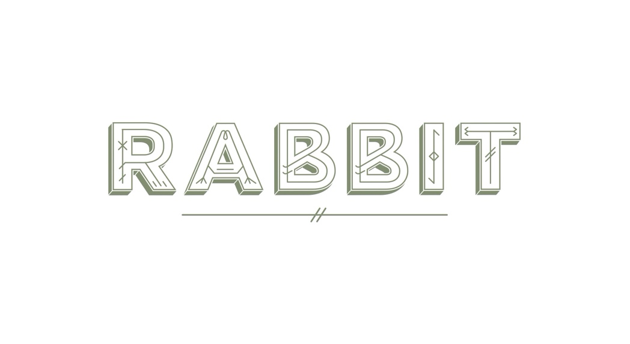

SUNDAYS ON THE FARM
From Saddleback Pork to Sussex Beef and South Downs Lamb, our meat is sustainably sourced from our bio-dynamic farms in West Sussex, and neighbouring Red Tractor approved farms.
RABBIT PICKLEHOUSE BLOODY MARY
Adnam’s First Rate Vodka, Pickle House tomato juice, celery, lemon

RABBIT BREAD, ROSEMARY BUTTER 5.0
MUSHROOM MARMITE ÉCLAIR, EGG CONFIT, CORNICHON 3.5 each
GOAT CHEESE TARTLET, MINT 3.5 each
PADRON PEPPER, HONEY, GARLIC 5.0
OWELETTS FARM MEATBALLS, NUTBOURNE TOMATO, PECORINO, BASIL 3.5/8.0

~

MACKEREL, GREEN APPLE, LIMPFISH ROE 13.5
HACKNEY BURRATA, NUTBOURNE CONFIT VEGETABLES, ALMONDS, CHIVES 13.5
CURED TROUT, DILL EMULSION, THREE CAVIARS, NORI 14.5

~

CONFIT AUBERGINE, SHALLOTS, BASIL, ONION JAM 18.0
LINE CAUGHT HALIBUT, SWEET AND SOUR VEGETABLES, DILL, CAVIAR SAUCE 32.0

SUNDAY ROAST
All roasts are served with roast potatoes, Yorkshire Pudding, and seasonal vegetables.

CONFIT AUBERGINE 19.0
CORN FED CHICKEN SUPREME 22.0
SLOW ROASTED PORK SHOULDER 25.0
DORSET LEG OF LAMB 26.5
LYON’S HILL FARM BEEF SIRLOIN 28.0

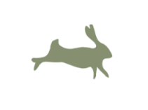

CHEESEBOARD, CRISPBREAD, HONEY 15.0
CAVE AGED CHEDDAR, BATH SOFT, CASHEL BLUE, MICHAEL’S MOUNT
~
SWEETCORN SET CREAM, PEACH AND APRICOT 8.0
CITRUS RASPBERRY TART, BAKED WHITE CHOCOLATE 8.0
CHOCOLATE BROWNIE, TOFFEE SAUCE, RED CURRANT 8.0

@RABBIT_RESTO
GAME DISHES MAY CONTAIN SHOT.
PLEASE LET US KNOW IF YOU HAVE ANY ALLERGIES OR DIETRY REQUIEMENTS SO WE CAN MAKE SUITABLE SUGGESTIONS.
A DISCRETIONARY SERVICE CHARGE WILL BE ADDED TO YOUR BILL.

